|  |
| --- |
| **Module Code & Title:** EGR3039 Industrial Automation |
| **Contribution to Final Module Mark (module weighting):** 30% |
| **Coursework Title: Coursework** 1 |
| **Description of Assessment Task and Purpose:**  Refer to the problem statement in **Appendix 1** and perform the following tasks:   1. List out the number and types of *sensing, actuating and control elements* in the given case if it were to be automated by ***pneumatics only***. 2. Search for an industrial task which is performed manually that can be automated using the pneumatic only components you identified and listed in task (i) above. 3. Automate this new task, for the automation, make ***pneumatic circuit*** diagram in Fluid-SIM software and perform the same on hardware with proper ***pneumatic only*** components. |
| **Learning Outcomes (LO) Assessed:**  LO1 Consolidate and extend a systematic and coherent body of knowledge on modern industrial automation architectures, technologies, and appropriate industry standards.  LO2 Demonstrate an advanced knowledge and critical understanding of the main characteristics of sensors and actuators, including their interconnection with the control system.  LO3 Demonstrate an appreciation of main principles of real-time network systems. |
| **Knowledge & Skills Assessed:**  Subject Specific Knowledge, Skills and Understanding, Professional Graduate Skills. |
| **Assessment Submission Instructions:**  This submission is an **individual** work.  You are required to submit your assessment in either Word or PowerPoint format using the Turnitin online assessment submission facility on the module Blackboard site.  All work should be submitted by the deadline stated above. Any late submissions will be subject to a lateness penalty in line with the University policy.  The method of submission described above should be used in the first instance however, in cases of technical issues please email your assessment to: [sepssubmissions@lincoln.ac.uk](mailto:sepssubmissions@lincoln.ac.uk) by the above deadline. Please include the module code and coursework title in the email subject.  All work will be subject to plagiarism and academic integrity checks. In submitting your assessment, you are claiming that it is your own original work; if standard checks suggest otherwise, Academic Misconduct Regulations will be applied. |
| **Format for Assessment:**  Your submissions will include the following:   1. A 2-page (A4 size) report consisting of the following: 2. List of components identified, clearly categorized as sensing, actuating or control element. 3. A short description of the industrial task that you identified. 4. Sequence wise list of steps needed to automate this industrial task. 5. The FluidSIM software project file having your simulation of the automated task correctly running on it. 6. A copy of lab sheet (**Appendix 2**) provided on lab day duly signed by the instructor.   Take these files, Zip them all together and submit them by uploading on Turnitin. |
| **Marking Criteria for Assessment:**  This assessment will be marked out of 100 marks with 30% weightage towards the final module mark. Marks will be allocated as per the following distribution for appropriate structure and format of the report and demonstration of an understanding and appreciation of the context and theoretical background to the work:   1. The 1-page report – 2. Correct number and types of sensing, actuating and control elements in the given cases in Appendix 1. **(10 marks)** 3. The correctness and appropriateness of the chosen industrial task. **(10 marks)** 4. List of steps to automate the industrial task and the correct sequence. **(10 marks)** 5. The FluidSIM software project file – 6. Correct choice of components on the software for the problem statement. **(10 marks)** 7. Correct simulation on Fluid SIM software. **(20 marks)** 8. The lab sheet (**Appendix 2**) provided on lab day duly signed and marked by the instructor. List and demonstrate the correct type of: 9. actuators on your hardware board. **(10 marks)** 10. sensors on your hardware board. **(10 marks)** 11. valves on your hardware board. **(10 marks)** 12. The fully functioning circuit on hardware. **(10 marks)**   ***Please note that all work is assessed according to the University of Lincoln*** [***Management of Assessment Policy***](https://cpb-eu-w2.wpmucdn.com/blogs.lincoln.ac.uk/dist/8/8024/files/2019/07/Management-of-Assessment-Policy.pdf) ***and that marks awarded are provisional on Examination Board decisions (which take place at the end of the Academic Year.*** |
| **Feedback Format:**  Feedback will be provided via the Turnitin online assessment submission facility on the module Blackboard site, under the ‘Feedback Summary’ tab. |
| **Additional Information for Completion of Assessment:**  N/A |
| **Assessment Support Information:**  Any needed support may please be directed via email to [fiqbal@lincoln.ac.uk](mailto:fiqbal@lincoln.ac.uk) |
| **Important Information on Academic Integrity:**  The use of AI tools is Not Permitted  All work will be subject to plagiarism and academic integrity checks. In submitting your assessment, you are certifying that this is entirely your own work, without input from either commercial or non-commercial writers or editors or advanced technologies such as artificial intelligence services unless explicitly allowed and referenced. If standard checks suggest otherwise, Academic Misconduct Regulations will be applied. |

**Appendix 1**

**Refer to Figure 1 below.** Cylinder 1A is to push parts out of the gravity feed magazine and clamp them. Only then can cylinder 2A stamp the part and retract once again. Next, clamping cylinder 1A is to unclamp. The part is to be ejected by cylinder 3A, which then returns to the retracted end position.

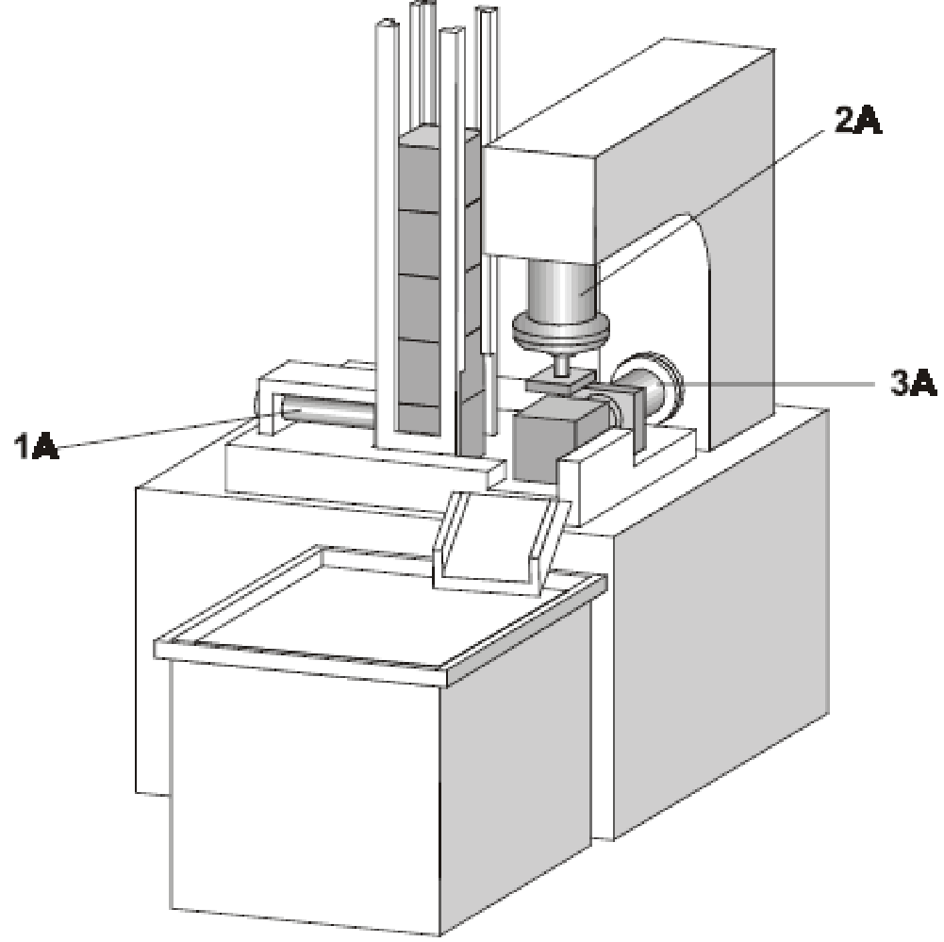

**Figure 1**

**Appendix 2**

**Lab Sheet**

**Worksheet for automation of chosen industrial task.**

|  |  |  |  |
| --- | --- | --- | --- |
| **Serial No.** | **Question** | **Student response** | **Instructor Approval and remarks for marking after submission.** |
| **1** | List and demonstrate the correct type of actuators on your hardware board |  |  |
| **2** | List and demonstrate the correct type of sensors on your hardware board |  |  |
| **3** | List and demonstrate the correct type of valves on your hardware board |  |  |
| **4** | Demonstrate the correct functioning of the circuit on hardware. |  |  |